**Email #1**

**Subject Lines:**

* This is a Rainy Day Activity to Put at the Top of Your Priority List
* Life is What Happens When You are Making Other Plans
* You’re Invited to the Next Life Goes on Roadmap™ Virtual Road Trip

Dear First Name,

Today I am sharing a special invitation for you to benefit from a rainy day activity that can be among the most empowering steps you take this year.

It’s about getting your personal financial information and crucial documents organized to when life happens when you are making other plans, you aren’t caught with your pants down.

My friend Nancy Juetten and her husband Steve Juetten created a program called Life Goes on Roadmap™. This is an empowering toolkit to get on the same page when it comes to organizing your personal finance information for today’s digital age. The end result is that you have power, access, and control, ***before*** a natural disaster, home burglary, disease, disability, disability or death get in the way.

You welcome financial peace of mind when you organize important contacts, service providers, insurance information, bank or credit union accounts, investments, credit cards, and more so the information is accessible when and where it is needed.

Life Goes on Roadmap elevates the process of getting organized to be **a game to win** instead of an administrative task to put off until later.

Unlike old fashioned paper systems, Life Goes on Roadmap is suitable for today’s digital age. It offers a safe and secure way to enter, save, update, and share the information that covers 16 important pages of crucial information with the right people who have a need to know.

In today’s online and electronic world in which people have hundreds of online accounts and subscriptions, a safety deposit box with insurance papers and a short letter no longer do the job.

It’s one thing to receive these tools. It’s another to actually use them to get your personal financial life in order.

That’s where Nancy and Steve’s system comes in. They actually hold your feet to the fire to get this done as they make it fun for you.

Here’s the exciting news.

* They offer virtual get it done days to take the Life Goes on Roadmap Virtual Road Trip and receive all the materials that go with it.
* They will guide you and others you invite to get your acts together, so everyone is empowered to drive life forward, no matter what life serves up next.

Here’s what to do so you can join us:

1. Visit [www.partnerlinkhere.com](http://www.partnerlinkhere.com/) to read about the Life Goes on Roadmap™.
2. Make your purchase.
3. Join Nancy and Steve for a 15-minute Ready Set Go Prep Call so you can prepare for the road ahead.
4. Choose a date and be guided to get this done as they make it fun.

I urge you to register so you can benefit in this personal, profound and practical way.

Warmly,

Your Name Here

**Email #2**

**Subject Line:**

Did you Register Yet for the Life Goes on Roadmap™ Yet?

Dear First Name,

Partners in relationships divide responsibilities differently when it comes to paying the bills, managing the household, and managing investments.

**Could it be that one partner in your relationship has more power than the other?**

**And could now be a good time to revisit that?**

My friends Nancy and Steve Juetten of Life Goes on Roadmap™ have been hearing some cautionary tales from the road of life from dozens of women and a few brave men who have told us that not all is well in personal finance management paradise.

It's been sobering, to say the least.

Here are two of those tales from the many they’ve received so far:

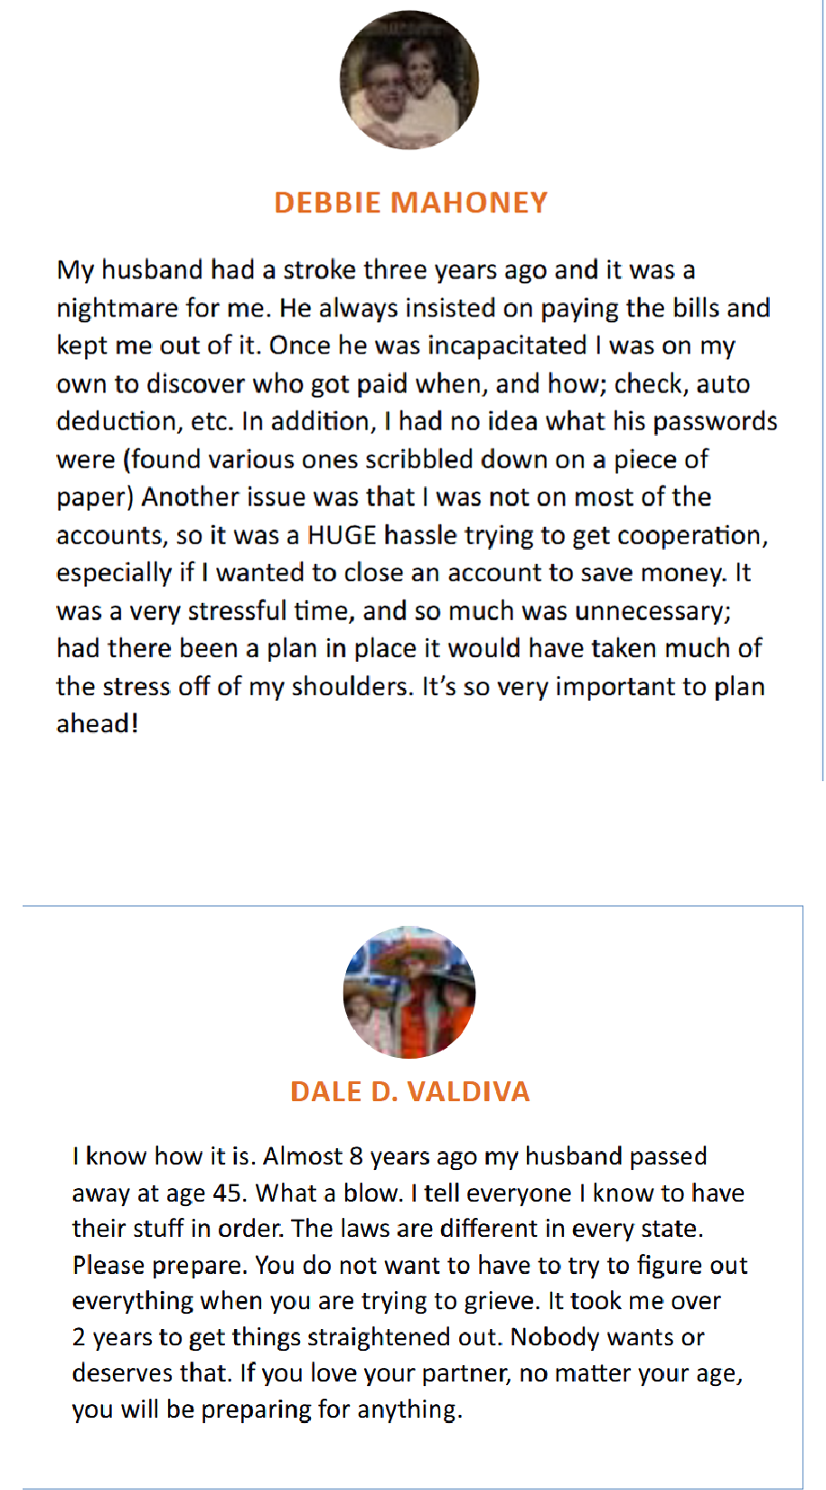

That's why they want to do their part to inspire couples and those they love to get on equal footing sooner versus later.

It's far better to get ahead of potential problems before they become major issues, don't you agree?

Today I am sharing a special invitation for you and those you love.

You’re invited to join us and benefit from a powerful virtual day of support, training, and accountability to get your personal financial information organized so you can be ready for whatever life serves up without having to scramble to find account passwords, security questions, and other important details.

Life Goes on Roadmap™ is an empowering toolkit to organize personal finance information for today’s digital age so you have power, access, and control, ***before*** a natural disaster, home burglary, or any of the four D’s -- disease, disability, divorce, or death get in the way.

You welcome financial peace of mind when you organize important contacts, service providers, insurance information, bank or credit union accounts, investments, credit cards, and more so the information is accessible when and where it is needed.

Life Goes on Roadmap elevates the process of getting organized to be **a game to win** instead of an administrative task to put off until later.

Unlike old fashioned paper systems, Life Goes on Roadmap is suitable for today’s digital age. It offers a safe and secure way to enter, save, update, and share the information that covers 16 important pages of crucial information with the right people who have a need to know.

In today’s online and electronic world in which people have hundreds of online accounts and subscriptions, a safety deposit box with insurance papers and a short letter no longer do the job.

It’s one thing to receive these tools. It’s another to actually use them to get your personal financial life in order.

That’s where Nancy and Steve come in. They actually hold your feet to the fire to get this done as they make it fun for you.

Here’s the exciting news.

* Nancy and Steve are offered virtual Get It Done days. You get to complete your Life Goes on Roadmap™ and receive all the materials that go with it. You can extend the same invitation to your friends and family. They will guide you to get this done so you can be empowered to drive your life forward, no matter what life serves up next.

Here’s what to do so you can join us:

* Visit partnerlinkhere to read about the Life Goes on Roadmap™.
* Make your purchase.
* Tune in for a Ready Set Go Prep Call so you can prepare for the road ahead.
* Get this done as Nancy and Steve make it fun.

I urge you to [register](http://www.authenticvisibility.com/roadmap) so you can benefit in this personal, profound and practical way.

Warmly,

Your Name Here

Email #3

**The Life Goes on Roadmap Bus is Leaving the Station – Did You Get Your Ticket to Ride?**

Dear First Name,

Partners in relationships divide responsibilities differently when it comes to paying the bills, managing the household, and managing investments.

**Could it be that one partner in your relationship has more power than the other?**

**And could now be a good time to revisit that?**

Today I am sharing an invitation for you and those you love.

Join Nancy and Steve Juetten of Life Goes on Roadmap™ for a powerful virtual day of support, training, and accountability to get your personal financial information organized so you can be ready for whatever life serves up without having to scramble to find account passwords, security questions, and other important details.

Life Goes on Roadmap™ is an empowering toolkit to organize personal finance information for today’s digital age so you have power, access, and control ***before*** disease, disability or death get in the way.

You welcome financial peace of mind when you organize important contacts, service providers, insurance information, bank or credit union accounts, investments, credit cards, and more so the information is accessible when and where it is needed.

Life Goes on Roadmap elevates the process of getting organized to be **a game to win** instead of an administrative task to put off until later.

Unlike old fashioned paper systems, Life Goes on Roadmap is suitable for today’s digital age. It offers a safe and secure way to enter, save, update, and share the information that covers 16 important pages of crucial information with the right people who have a need to know.

In today’s online and electronic world in which people have hundreds of online accounts and subscriptions, a safety deposit box with insurance papers and a short letter no longer do the job.

It’s one thing to receive these tools. It’s another to actually use them to get your personal financial life in order.

That’s where Nancy and Steve Juetten come in. They actually hold your feet to the fire to get this done as they make it fun for you.

Here’s the exciting news.

* Nancy and Steve Juetten will guide you to get this done so you can be empowered to drive your life forward, no matter what life serves up next.

Here’s what to do so you can join in:

* Visit www.partnerlinkhere.com to read about the Life Goes on Roadmap™.
* Make your purchase.
* Join Nancy and Steve for a Ready Set Go Prep Call so they can prepare you for the road ahead.
* Get this done as they make it fun.

I urge you to [register](http://www.authenticvisibility.com/roadmap) so you can benefit in this personal, profound and practical way.

Warmly,

Your Name Here









