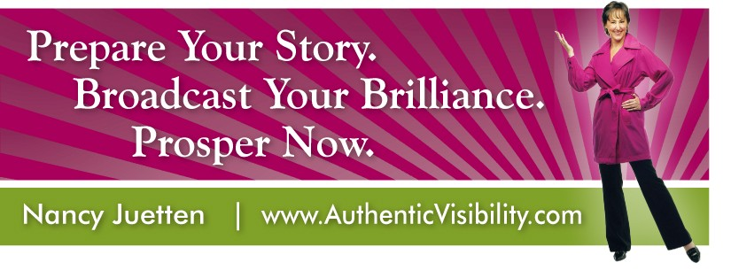
nancy@authenticvisibility.com, 425-641-5214

Rock Star Status Reality Check

Yes No

⁯ ⁯ My head shot looks great and looks like my current reflection in the
mirror.

⁯ ⁯ I have a link to my compelling short bio on my website or blog to
share with every media query, pitch, and opportunity I seek.

⁯ ⁯ When CNN Radio or NPR Radio call, my two-sentence radio
introduction and my five favorite questions to be asked and
answered are ready to share at a moment’s notice.

⁯ ⁯ My teleseminar packet is ready to share with my joint venture
partners to set the stage for an amazing presentation, earn a ‘wow’
and invite repeat visits.

⁯ ⁯ My most popular and in-demand speaking topic shows up as a
bold headline on my speaker page.

⁯ ⁯ I have a compelling speaker introduction that captures attention
and brings people to their feet before I speak my first word.

⁯ ⁯ My Twitter profile is alive with personality and credibility.

⁯ ⁯ My ‘bio box’ for online article submissions makes it easy and
compelling for readers to opt-in-to my ezine, rush to get my special
report, and become a fan and follower of my work.

If there are a lot of checks in the NO column, this is YOUR wake-up call to get into action so you can be in good position to earn the expert status you seek.

Visit this link to find the “perfect fit” solution to get ready right now.

