**Email #1**

**Subject Line:** Join us March 9 to complete your Life Goes on Roadmap

Hi (First Name),

I'm excited to share with you the Life Goes on Roadmap™. It's a powerful system to guide you and your family to assemble the information you need to grab the wheel, take control, and steer your life in the right direction if something random, sad or crazy should happen to you or someone in your family.

[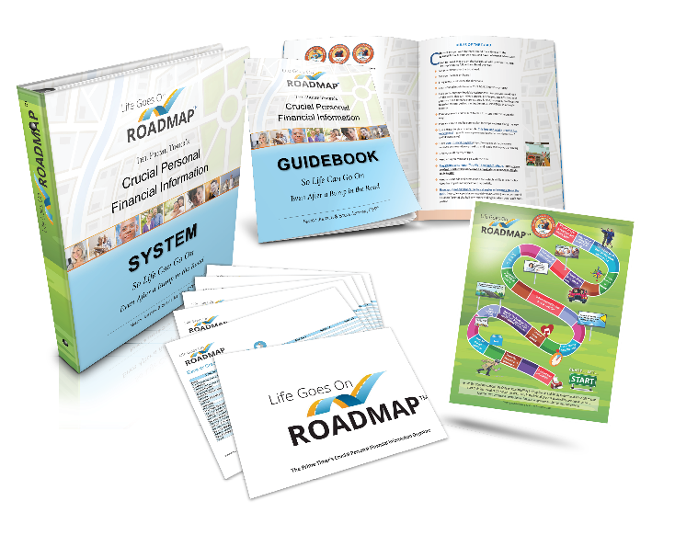](http://www.on2url.com/lnk?MzA5ODE5N3wxNDA1NjMxODJ8cz0x)

Very soon, you'll have power, access, and control to unlock the keys to much of what is most important in your life ***before*** life hits a bump in the road.

This is your invitation to save the dates for the LIVE training calls coming up soon.

* Save **March 6, 2019, at 6 p.m. Pacific** for the Ready Set Go Prep call so you can pack for a fabulous virtual road trip and get excited about what to expect.
* Save **March 9, 2019 from 9 a.m. - 2 p.m. Pacific** for our live virtual Get It Done Day so you can cruise your way to completion with expert support and have plenty to celebrate!

If you are unable to join us live, you will receive the replays so you can get this mission accomplished on a date that works for you.

To get excited about what this training has to offer and participate without fee, please visit this page -- [www.lifegoesonroadmapNOW.com](http://www.lifegoesonroadmapNOW.com) -- and use this VIP Code -- insert yours here -- when you select "purchase the digital version now."

Then, you'll be all set to receive all the digital goodies and the live (or recorded) support and reminders to get this done.

The founders of Life Goes on Roadmap™ will be guiding you on this journey.

I'll be standing by to support you with any questions you have or any new plans you'd like to make as a result of the lessons and AHA insights you gain along the way.

Looking forward to celebrating with you when you become an "I'm Ready for Anything Road Tripper!" and exploring what might be next along your journey.

Warmly,

Your Name Here



P.S.  Getting this done in the community makes it a whole lot more fun. In a few hours, you'll get your life-and-death ducks in a row so the rest of your life can be smoother swimming for you and those you love.  Ahhhh!

P.P.S. If you know of someone who would appreciate the extraordinary level of service I provide, please call me with their name and number at insert your phone number here. I'll be happy to follow up and take great care of them.

**Email #2**

**Subject line:** Stop wondering about 'what ifs' [First Name], starting on March 9!

Hi (First Name),

It's so important to get on the same page about money matters BEFORE someone gets sick or dies. Don't you agree?

And here's a solution. It's called Life Goes on Roadmap™.

As my gift to you, you’re invited to join us and benefit from a powerful virtual day of support, training, and accountability to get your life-and-death ducks in a row so the rest of your life can be much smoother swimming.

When you do:

* You and your loved ones can be ready for whatever life serves up without having to scramble to find the keys to unlock your life.
* You'll receive the easy to use tools and support you need to grab the wheel, take control, and steer life in the right direction before life takes a nasty turn.
* [Visit this link to claim your ticket to ride.](http://www.on2url.com/lnk?MzA5OTY1OXwxNDA1NjMxODJ8cz0x) Then, use this VIP code when you make the choice *to purchase the digital system now:* (Insert Your VIP Code Here). This allows you to benefit from the system as my gift to you!

All aboard! It all starts Saturday, March 9, starting at 9 a.m. Pacific.

Insert Your Name Here

P.S.  You can go with guidance or go it alone because replays are always provided.

P.P.S. This is your golden moment to put those 'what ifs' in the rear view mirror for good. It's all happening on Saturday, March 9.

**Email #3**

**Subject line:** Did you Get Your Life Goes on Roadmap™ Ticket to Ride? -- Licensee Email

(First Name Here),

It's decision time.

The Life Goes on Roadmap™ virtual bus is leaving the station this Saturday, March 9.

This is your opportunity to benefit from a powerful virtual day of expert support, training, and accountability to get your personal financial information organized so you can be ready for whatever life serves up without having to scramble to find account passwords, security questions, and other important details to unlock the keys to your life.

Visit [www.lifegoesonroadmapnow.com](http://www.on2url.com/lnk?MzA5OTY2NXwxNDA1NjMxODJ8cz0x) to get your ticket to ride. Then, use this VIP code to benefit from the digital system and the virtual training that goes with it as my gift to you: Insert Your VIP Code Here

You'll receive the tools and resources to get this done, whether you are able to attend the live training or not.

[All Aboard!](http://www.on2url.com/lnk?MzA5OTY2NnwxNDA1NjMxODJ8cz0x)

Insert Your Name Here

P.S.  If you are thinking about putting this off, don't. Something crazy, sudden or random could happen that can change everything. That's why getting ahead of that sort of thing can pay huge dividends and bring great peace of mind when it really counts.  Come on along!

P.P.S. Be sure to give me a call at insert your phone number here after you've reviewed the materials and completed your own Life Goes on Roadmap™. If there is more follow up we need to do to make sure you and your family are ready for a bump in the road, I look forward to being of service.